
Photo credit: Tophetheshooter

Vanessa Paradis and her team put Spectera handheld to the test
On her 2026 tour, the wideband wireless system gives peace of mind to engineers and artists

Paris, June 2026 – For Vanessa Paradis’ 2026 tour, the audio team around monitor engineer Matthieu Speck have adopted Sennheiser’s Spectera wireless system, including the new SKM handheld transmitter. The tour is visiting an exciting mix of big arenas, large indoor venues and festivals, so the team was looking for a system that would be reliable, with stable RF and transparent audio – in brief: capable of building complete trust with the artist from the very first soundchecks.

The set-up for this tour includes two Sennheiser Spectera Base Stations, complemented by a backup unit, and 28 SEK bodypacks. Two Spectera handheld microphones handle the vocals; the monitoring is operated at 96 kHz. Eight Neumann MCM 114 clip-on microphones pick up percussion and brass, while four MKH 8018 stereo shotgun microphones capture the audience ambience.

Alongside Matthieu Speck at monitors, Vanessa Paradis’ audio team includes Julien Decarne (FOH), Nelly Robert (RF) and François Kerjan (sequencing).

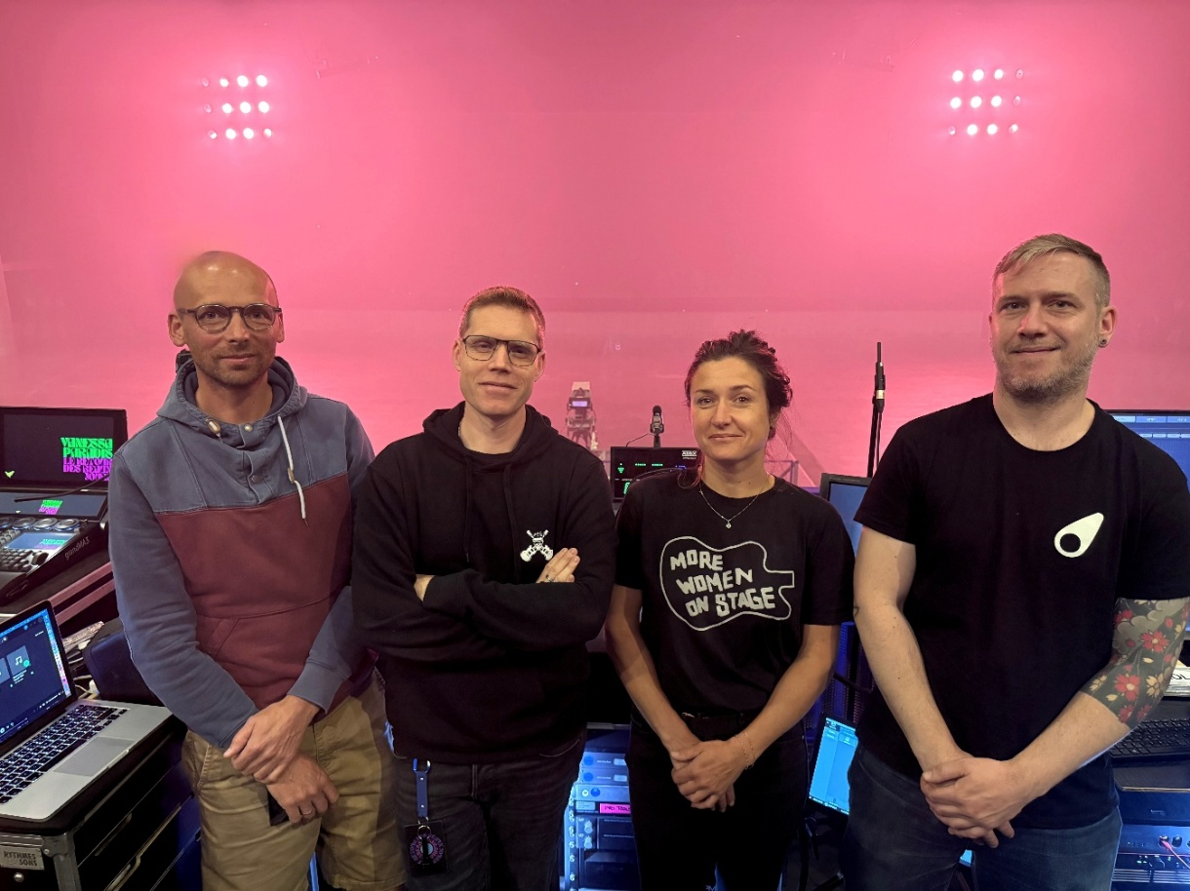
Vanessa Paradis’ audio team (left to right): Julien Decarne (FOH), Matthieu Speck (Mons), Nelly Robert (RF), François Kerjan (sequencing). Photo credit: Matthieu Speck

A decision driven above all by trust
For Matthieu Speck, the main challenge was to integrate a new technology into a demanding live production. For Vanessa Paradis, who usually sings with wired microphones, adopting a wireless microphone represented a significant step.

“Vanessa has sung with wired microphones her entire career; this is the first time she has accepted using a wireless mic on stage. Quality and reliability are a must,” points out Speck.

This level of expectation shapes the entire approach to the tour. Spectera is seen as a solution that safeguards the connection between the artist, the musicians, and the production team, ensuring continuity in an environment where each show presents its own constraints.

Simpler and faster RF management
One of Spectera’s key advantages lies in its special wideband technology which allows both bidirectional audio and control data to be carried within a single RF channel using time slots. This replaces the traditional RF coordination approach and significantly simplifies set-up and operation.

“The Sennheiser WMAS technology replaces the traditional frequency plan. It is an extremely stable and more intuitive approach,” explains Speck.

The time savings with wideband are particularly evident when fast set-ups are required, especially at festivals. Nelly Robert, RF manager of the tour, benefits from a significantly simplified workflow for RF set-up, as well as for deploying packs and preparing the microphones. The absence of repeated manual synchronisation allows the team to focus more on stage control, soundchecks and listening.

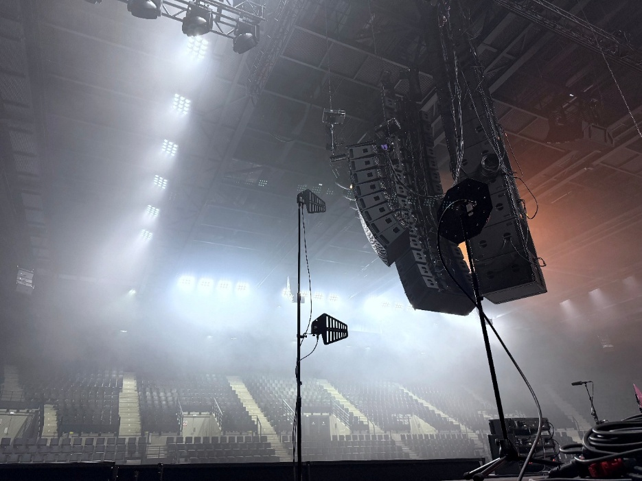 | Spectera DAD antennas on stage. Photo credit: Matthieu Speck

Proven RF stability in real-world conditions
The tour sees the system deployed in a wide range of environments: large venues, festival set-ups, coexistence with other RF wireless systems, and frequent changes of location. In this context, RF robustness is critical.

Speck highlights the range and reliability he has already observed on the road: “Spectera links are even more robust than we imagined before the tour. The range is excellent — even at the very top of the Zénith arena in Lille, France, we were unable to break the link, no matter whether the SKM handheld or the SEK bodypack was used.”

The system also works seamlessly with the SK 6000 used for backline communications, confirming its ability to integrate into a complex RF architecture without compromising operational reliability.

Greater autonomy for musicians, full control for the engineer
On stage, ease of use plays an important role for the acceptance of a new wireless system. On their SEK bodypacks, the musicians can make the most important settings themselves, reducing demands on the engineering team and improving their daily workload.

This autonomy still has some boundaries thanks to the Remote Lock function that allows Nelly Robert to lock critical functions remotely during the show. This means the system strikes a balance between user freedom and operational safety: musicians gain comfort, while the engineer retains control of essential parameters.

96 kHz in-ear monitoring: a new level of precision
In-ear monitoring is one of the areas where the change is most noticeable. For Speck, quality is now retained right through to the end of the signal chain.

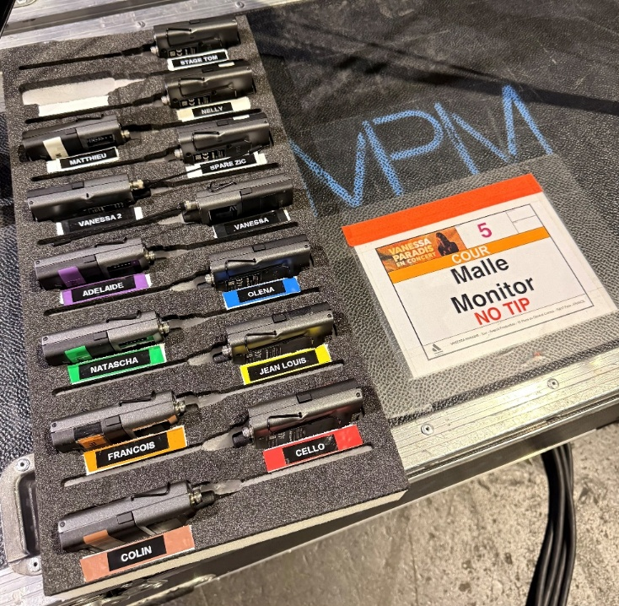 | For in-ear monitoring, Matthieu Speck uses digital transmission at 96 kHz for enhanced definition and a precise stereo image. Photo credit: Matthieu Speck
“Before Spectera, the weakest link in the audio chain was wireless in-ear transmission. We’re fortunate to have excellent consoles and high-performance tools across the board, and now we can maintain that quality all the way through. It’s a major step forward,” he says.

The move to digital transmission at 96 kHz brings greater definition and a more precise stereo image. Speck compares this evolution to moving from a standard-definition video image to the sharpness and detail of 4K. This transparency, however, introduces an additional demand: the system reveals everything that is sent through it. Precision therefore not only becomes a convenience for the performers, but is also required from the monitor engineer.

MKH 8018s recreate the connection with the audience
For Vanessa Paradis, in-ear monitoring must not isolate her from the energy of her audience. Capturing ambience therefore plays an important role, with four MKH 8018 stereo shotgun microphones on the job. The tiers are captured with two MKH 8018 set to narrow XY stereo, the stalls are picked up by two 8018s set to wide XY stereo. This set up reproduces a coherent and natural sound image of the venue without compromising mix clarity.

“I have never before achieved such good coherence in ambient capture; this has improved so much,” notes Speck.

MCM 114 on percussion and brass
Instrument capture relies on eight Neumann MCM 114 microphones, used on congas, bongos, saxophones and trombone. These sound sources are very demanding in respect of their dynamics and spectrum, which is why FOH engineer Julien Decarne ran various trials during rehearsals.

Combined with the SEK bodypacks, the MCM 114 allow a precise, detailed and musical reproduction without sounding harsh. This consistency across the signal chain, from capture, to transmission and monitoring, directly contributes to the musicians’ listening experience.

The service provider’s perspective: meeting the needs on the ground
MPM AUDIOLIGHT is the service provider and rental company for Vanessa Paradis’ set-up, and sees Spectera as a concrete response to the requirements of productions, sound engineers and technicians.
David Nulli, Operations Director at MPM AUDIOLIGHT, emphasises that the investment in Spectera is part of a strategy of keeping abreast of technological developments and reflects the company’s confidence in the quality of Sennheiser products: “As the Spectera system was in high demand among our customers right from its launch, and given the long-standing trust we have in the quality of Sennheiser products, we did not hesitate to invest in this solution at an early stage.”
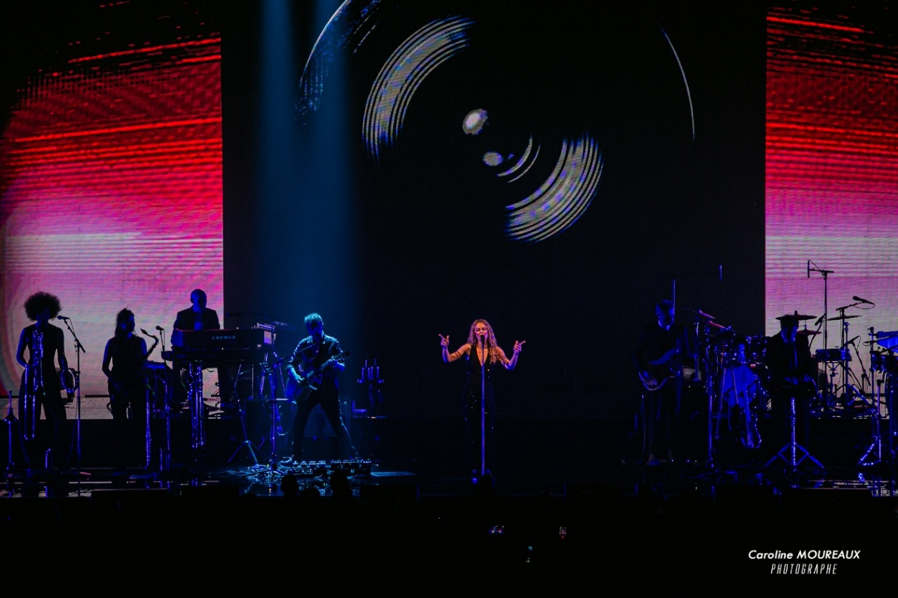
Photo credit: caroline.moureaux.photographe

There are also operational benefits for MPM AUDIOLIGHT: Faster preparation in the warehouse, simplified setup, and efficient deployment on site. This speed contributes to greater peace of mind for the teams and allows them to focus on the real challenges of the show.

David Nulli believes that Spectera is set to become the new standard for demanding productions, thanks in particular to its flexibility, reliability and alignment with the expectations of the high-end market.

The Pioneer Program: a direct link between field use and development
Vanessa Paradis’ tour is part of the Spectera Pioneer Program. For Speck, this programme has established a direct dialogue between touring engineers and Sennheiser’s development teams.

“With the Spectera Pioneer Program, we can communicate with the people writing the code… it has broken down that barrier between the development engineers of a brand and the engineers and technicians on the ground like us,” he says.

This exchange, notably via Discord, facilitates field feedback, adjustments and a better understanding of real-world operational constraints. The speed of updates, such as version 1.3, which can be installed in a matter of minutes, reinforces the impression of a system designed for the fast pace of live productions.

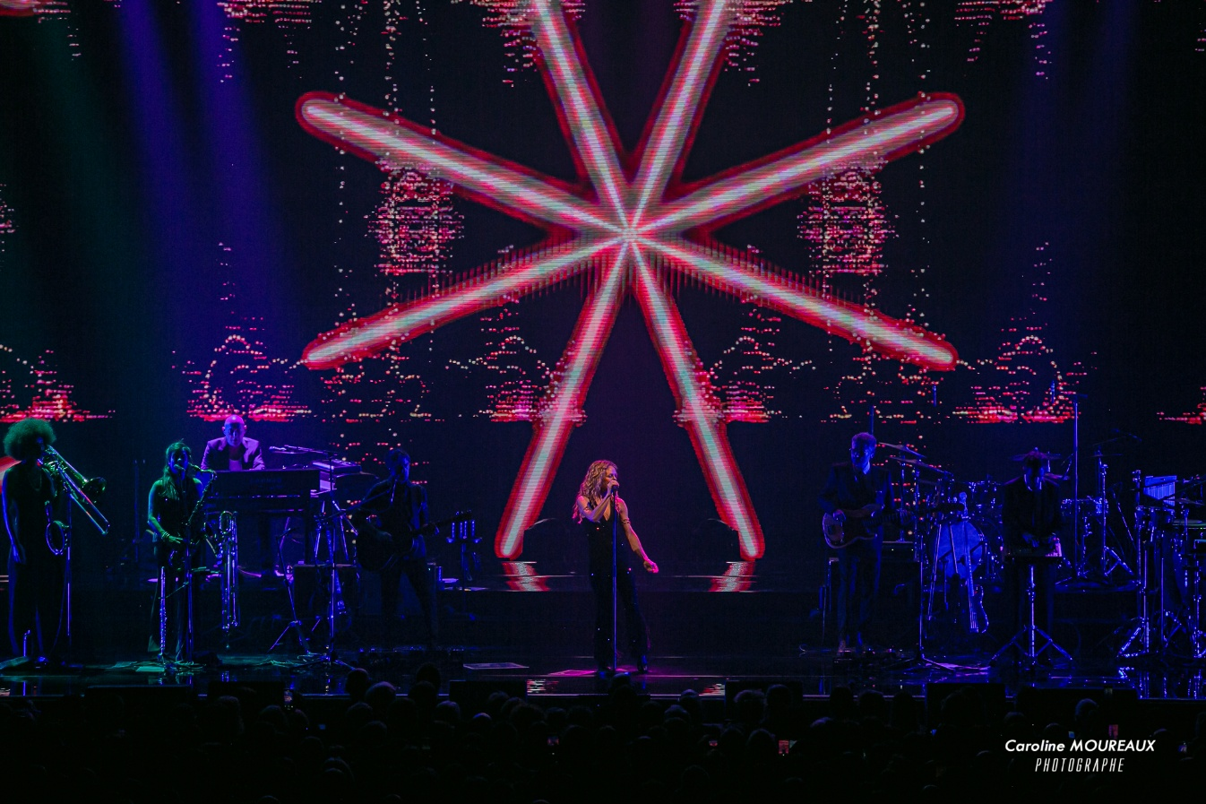
Photo credit: caroline.moureaux.photographe

When technology becomes invisible
Ultimately, the most important validation remains the artist’s. Vanessa Paradis quickly approved the sound definition in her in-ears, thereby confirming that the system met its main objective: building trust.

“Once that’s sorted, you create trust. My aim is for her to enjoy being on stage — that’s when I know I have done my job,” says Speck.

Decarne is also very pleased with the sound quality of Spectera: “Vanessa’s voice is remarkably clear and precise. This allows me to maximise intelligibility and ensure that every word is perfectly understood by the audience.”

On Vanessa Paradis’ 2026 tour, Spectera stands out for its ability to make operations smoother, musicians more autonomous, the engineering team more efficient and the artist more at ease. In a live setting, it is precisely when technology takes a back seat that its value becomes clear.

(Ends)

The high-resolution images accompanying this media release can be downloaded here. Please remember to include the photo credits.

About the Sennheiser brand
We live and breathe audio. We are driven by the passion to create audio solutions that make a difference. Building the future of audio and bringing remarkable sound experiences to our customers – this is what the Sennheiser brand has represented for more than 80 years. While professional audio solutions such as microphones, meeting solutions, streaming technologies and monitoring systems are part of the business of Sennheiser electronic SE & Co. KG, the business with consumer devices such as headphones, soundbars and speech-enhanced hearables is operated by Sonova Holding AG under the license of Sennheiser.

www.sennheiser.com
www.sennheiser-hearing.com

Pro Audio Press Contact
Stephanie Schmidt
stephanie.schmidt@sennheiser.com
+49 (5130) 600 – 1275

